
Case study:
Sensor and
Actuator in
automobile

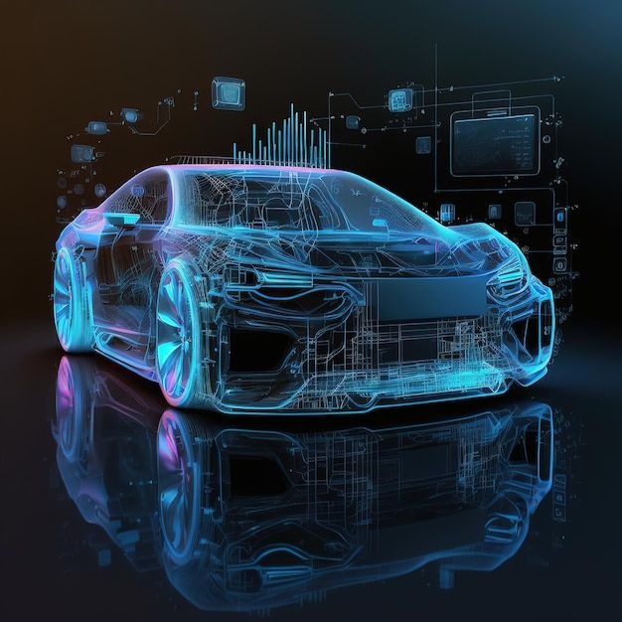
Introduction
In recent decades, the automotive industry has undergone significant technological advancements, largely driven by the integration of sensors and actuators. These components enable vehicles to monitor their environment and perform precise mechanical actions, enhancing safety, efficiency, and driving comfort. This case study examines the role, challenges, and impact of sensors and actuators in modern automobiles.

Overview of Sensors in Automobiles
Sensors are devices that detect changes in physical parameters and convert them into signals for monitoring and control. In automobiles, common sensors include:
- Oxygen Sensors:
Measure exhaust gas composition to optimize fuel combustion and reduce emissions.
- Tire Pressure Sensors:
Monitor tire inflation to improve safety and fuel efficiency.
- Temperature Sensors:
Track engine and ambient temperatures to regulate cooling systems.
- Proximity Sensors (Ultrasonic, Radar, Cameras):
Used in advanced driver-assistance systems (ADAS) for collision avoidance, parking assistance, and lane keeping.

Overview of Actuators in Automobiles:
Actuators receive control signals and convert them into mechanical movements or actions. Key actuators in vehicles include:
- Throttle Actuators: Control engine power by regulating air intake.
- Brake Actuators: Modulate braking force electronically, essential in ABS and electronic stability control.
- Fuel Injectors: Actuate the precise delivery of fuel into the engine cylinders.
- Electric Motors:
Used in power steering, window controls, and seat adjustments.
Integration and Control Systems:
Sensors and actuators are integrated into closed-loop control systems that enable real-time monitoring and adjustment of vehicle functions. For instance, the anti-lock braking system (ABS) uses wheel speed sensors to detect potential wheel lockup and actuators to adjust brake pressure, enhancing safety. Drive-by-wire technology replaces traditional mechanical linkages with electronic controls, improving precision and responsiveness.
Challenges in Sensor and Actuator Implementation:
Despite their benefits, the integration of sensors and actuators faces challenges such as:
- Environmental Durability: Sensors must operate reliably under extreme temperatures, vibrations, and exposure to contaminants.
- System Complexity: Increasing numbers of electronic components require sophisticated integration and communication protocols.
- Security Risks: Connected vehicle systems are vulnerable to cyber-attacks, necessitating robust cybersecurity measures
Impact and Future Directions
The adoption of sensor and actuator technology has led to significant improvements in vehicle safety, fuel economy, and driving experience. Looking ahead, advances in sensor accuracy, miniaturization, and actuator efficiency will support the development of autonomous vehicles and smarter transportation systems. Additionally, enhanced integration techniques and cybersecurity frameworks will be critical to address emerging challenges.

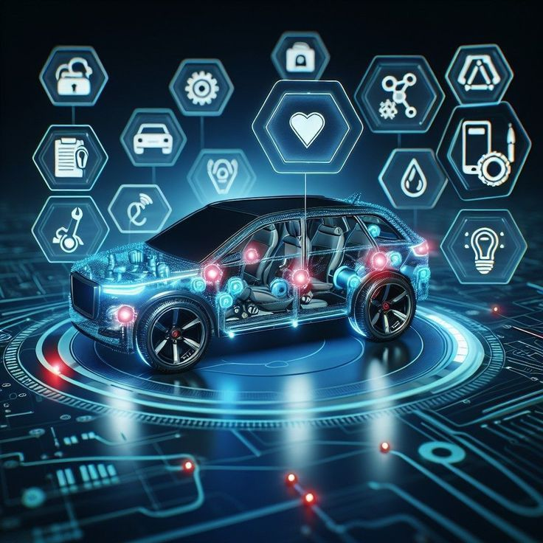

Conclusion
Sensors and actuators are fundamental to the evolution of modern automobiles, transforming them into intelligent and adaptive machines. This case study underscores their vital roles, the technological frameworks supporting them, and the ongoing efforts to overcome implementation challenges. The continuous advancement in these components promises to shape the future of automotive technology, emphasizing safety, efficiency, and innovation.

